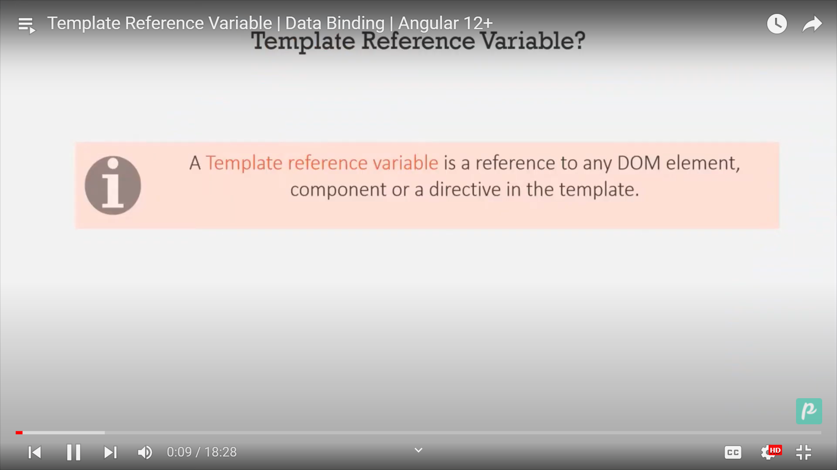

We will create a demo component.

Inside the demo component we will create a #myvariable(template variable)

<input type="tex" #myVariable />

Here myvariable will be act as reference variable to input element.

We will use keyup event to detect the change.

<div>

  <input type="tex" #myVariable (keyup)="(0)" />

  <p>You typed"{{ myVariable.value }}"</p>

</div>

It will display in

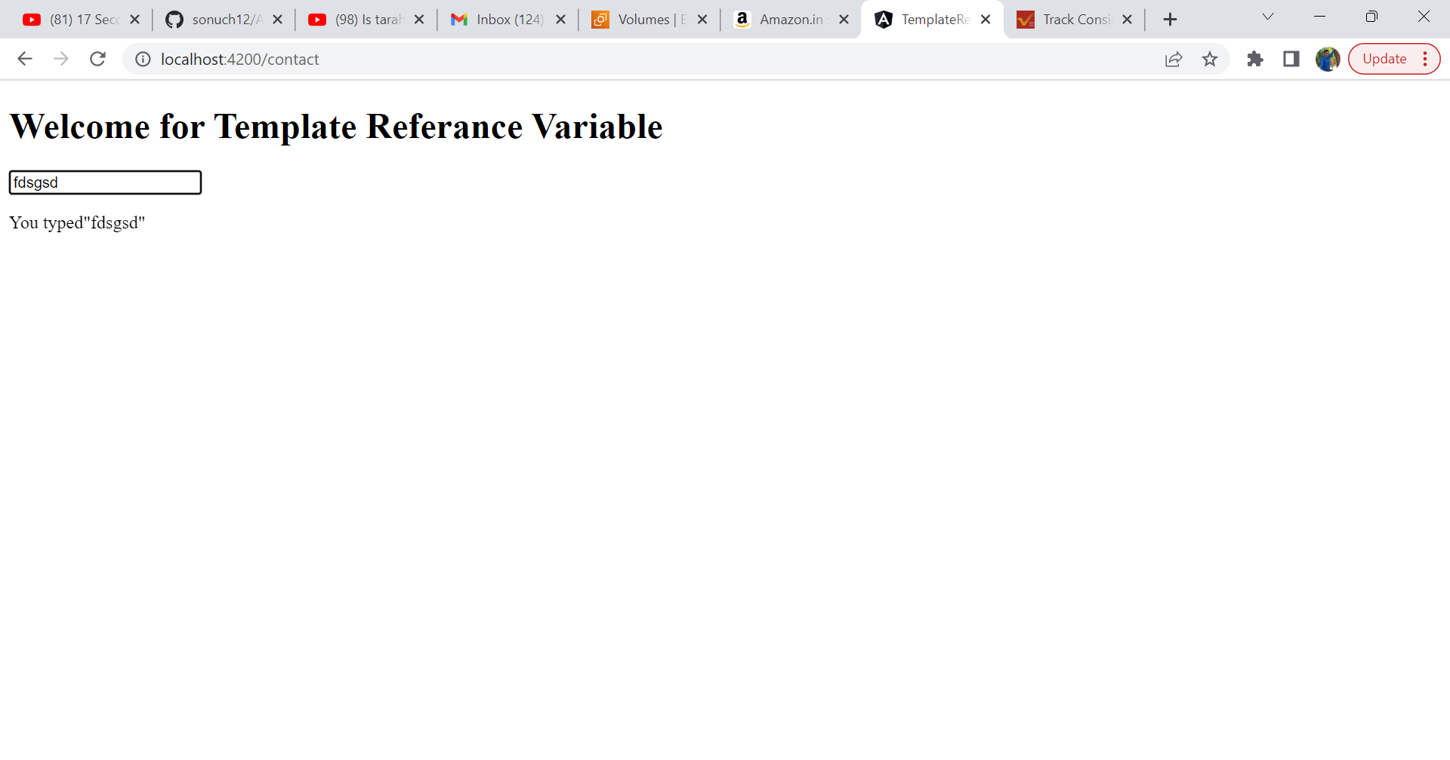

Now we will pass this #myVariable to component class.

We will create button on click of that button we will pass the value.

export class DemoComponent {

  sayHello(input: any) {

    alert('Hello  ' + input.value);

  }

}

  <button (click)="sayHello(myVariable)">Hello</button>

Now we will use this on a component.

We will generate customer-list component.

Inside that create a customer.ts file.

export class Customer {

  custId!: number;

  name!: string;

  address!: string;

  city!: string;

  country!: string;

}

Now create an array of object for customer

customers: Customer[] = [

    {

      custId: 121,

      name: 'Pam',

      address: 'Tarsali',

      city: 'Vadodara',

      country: 'India',

    },

    {

      custId: 2,

      name: 'Tam',

      address: 'Tarsali',

      city: 'Vadodara',

      country: 'India',

    },

    {

      custId: 3,

      name: 'Gam',

      address: 'Vatva',

      city: 'Ahmedabad',

      country: 'UK',

    },

    {

      custId: 4,

      name: 'Ram',

      address: 'Tarsali',

      city: 'Lucknow',

      country: 'USA',

    },

  ];

Now we will create view

<div \*ngFor="let customer of customers">

  <span> Id of customer is {{ customer.custId }}</span> &nbsp;&nbsp;

  <span> Name of customer is {{ customer.name }}</span> &nbsp;&nbsp;

  <span> Address of customer is {{ customer.address }}</span

  >&nbsp;&nbsp; <span> City of customer is {{ customer.city }}</span

  >&nbsp;&nbsp; <span> Country of customer is {{ customer.country }}</span

  >&nbsp;&nbsp;

  <button class="btn btn-success" (click)="selectedCustomer = customer">

    Selected

  </button>

</div>

The selected data is ther in selectedCustomer.

Now in

<app-customer-list #cust></app-customer-list>

<h3>You selected {{ cust.selectedCustomer?.name }}</h3>